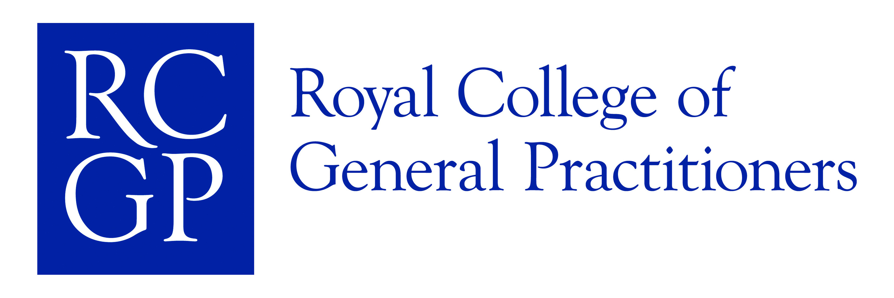
Page 1
Accreditation Number: 08/03-17 AKT/CSA
Venue: Lintonville Medical Group, Lintonville Terrace,
Ashington, Northumberland NE63 9UT
Date: 20th & 21st September 2008
Time: 08:45am-17:30pm

nMRCGP—CSA

£135.00 Northern Deanery RCGP AiT | £330.00 RCGP AiT
£255.00 Northern Deanery Non RCGP AiT | £450.00 Non-RCGP AiT
Course tutor: Dr Alan McCubbin

Day 1 08:45—17:30 | Day 2: 08:45-17:30
How to Deal With Simulated Cases | CSA Circuit 2 (Clinical)
The Consultation: revision of consultation & practical approach to CSA Cases | Circuit 2 Debrief
CSA Circuit 1 (Communication) | CSA Circuit 3 (Ethical)
CSA Circuit 1 Debrief & Introduction to CSA Circuit 2 | CSA Circuit 3 Debrief
 | Plenary / Feedback
Please note: Associates in Training from The Northern Deanery will receive a £195 subsidy, this has
already been reflected in the price. The course is open to all. Final Year AiTs will be prioritised.

Reply slip to: Clare Bartram, RCGP, The Surgery, Oxford Road, Spennymoor, Co. Durham,
DL16 7SQ—Tel: 01388 817518. Email: cbartram@rcgp.org.uk

Please make cheques payable to RCGP North of England

FULL NAME (block capitals please)

ADDRESS

Name of training practice:

Tel: | Fax: | Email
RCGP AiT number: |  | Price:
Please state if you are in your final AiT year.
Refunds will be made incurring a 10% admin fee, no refund if less that 14 days to the event.
Please state any dietary requirement.

